National Training Agency
Version 2.0

[TVET Control Centre User Manual – Training Provider Management]
To assist persons with the role of Training Providers in navigating the functions of the TVETCC.

Revision History

Version | Date | Revision Description | Last Edited by
1.0 | 02 Jan 2013 | Initial release | Nari Mohan
1.1 | 28 Jan 2013 | Content updated– Candidate Management | Nari Mohan
2.0 | Apr 2022 | Content and layout updated | MGD

Table of Contents
1.1.1. Revision History ii
1. Introduction 1
1.1. Purpose 1
1.2. Intended Audience 1
1.3. Acronyms and Abbreviations 2
2. Application Overview for Training Providers 3
2.1. Organization of Manual 3
2.2. Reference to other manuals 3
3. Getting Started 4
3.1. Accessing the TVET Control Centre 4
3.2. User Login Credentials 4
3.3. User Access Level 5
3.4. Changing Password 6
3.4.1. Password Recovery 6
3.5. Logging out 6
4. Using The Training Provider Main Panel 7
4.1. Profile Management 8
4.1.1. Manage Profile 8
4.1.2. Manage Satellite 8
4.1.3. User Accounts Management 9
4.2. Assessor Management 12
4.2.1. Assessor Search 12
4.2.2. Manage TP Assessor 13
4.3. Programme Management 15
4.3.1. Manage Programme 15
4.3.2. Statistic Management 17
4.4. Candidate Management 18
4.4.1. Manage Candidate 18
4.4.2. Candidate Registration 20
4.4.3. Candidate Uploader 21
4.5. Cycle Management 24
4.5.1. Assessor Cycle Management 26
4.5.2. Enrol Candidates into Cycle 27
4.6. Centre Approval 30
4.6.1. Centre Approval Management 30
5. Step-by-Step Guide for Training Providers 33
6. Error Handling 34
6.1. Common Errors 34
6.2. Help Facilities 34
7. Appendix A - Glossary 35

Introduction
The national TVET Control Centre (TVETCC) is a secure online database solution designed to collect and store information, within the TVET System, on:
- TVET Training Providers that are Enterprise, Community, Institution and School based
- Training Programs
- Trainers/Assessors
- Trainees/Graduates.
The TVETCC facilitates the interaction of stakeholders involved in the certification process towards the Trinidad and Tobago National Vocational Qualifications (TTNVQs) or Caribbean Vocational Qualifications (CVQs).
Stakeholders include the candidates, training providers’ administration, assessors, verifiers and the staff of the National Training Agency (NTA).

Purpose
The purpose of this manual is to provide all the necessary information to navigate the TVETCC as a training provider. The manual assumes that the user has a good knowledge of the certification process.

Intended Audience
This manual is intended for persons performing the role of the Training Provider such the head of the organisation, training manager administrative assistant etc.

Acronyms and Abbreviations
CVQ | Caribbean Vocational Qualification
NTA | National Training Agency
PLAR | Prior Learning Assessment and Recognition
RTP | Registered Training Provider
TTNVQ | Trinidad and Tobago National Vocational Qualification
TVET | Technical Vocational Education & Training
TVETCC | TVET Control Centre

Application Overview for Training Providers
The TVETCC allows a training provider to register for an account. On approval the organisation is given a user account. This user account allows a training provider to:
- Manage the training provider profile
- Manage user accounts for the training provider
- Manage the programme offered by the training provider (not CVQ or TTNVQ)
- Manage the assessors and internal verifiers associated to the training provider
- Manage the candidates associated to the training provider
- Manage training cycles
- View units awarded to candidates in the training cycles

Organization of Manual

Reference to other manuals
Please see the TVET Control Centre User Manual – Assessor Management for persons in the role of the assessor, internal verifier or external verifier.
Please see the TVET Control Centre User Manual – Candidate Management for candidates.

Getting Started

Accessing the TVET Control Centre
The TVET Control Centre is accessed via a web browser and is available on the World Wide Web. The url is www.ntatvetcentre.org .
The website is compatible with all major browsers: Google Chrome, Microsoft Edge, Mozilla Firefox, Safari, Netscape, Opera and Internet Explorer 6 and above. This is by no means an exhaustive list; there are smart phones and other hand-held devices which can also be used to gain access to the website technologies.
The General Public can browse the site, create searches, and gather general information. Some features of the site are restricted to privileged user accounts.

User Login Credentials
User credentials refer to the paired username and password which is required to allow a user access to the website. The paired key is used to uniquely identify each user to the system. Users should make every effort to secure these keys to ensure that only authorized persons gain access and to prevent unwanted exploitation of the user’s account.
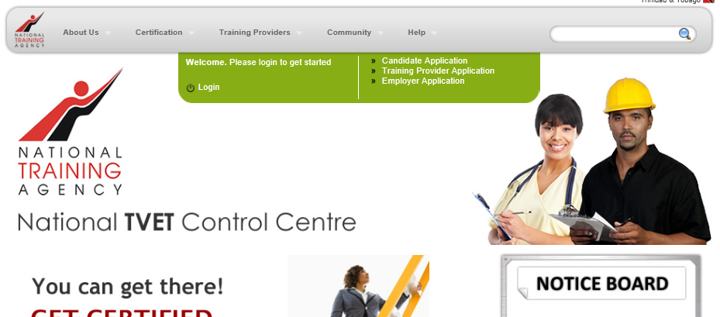
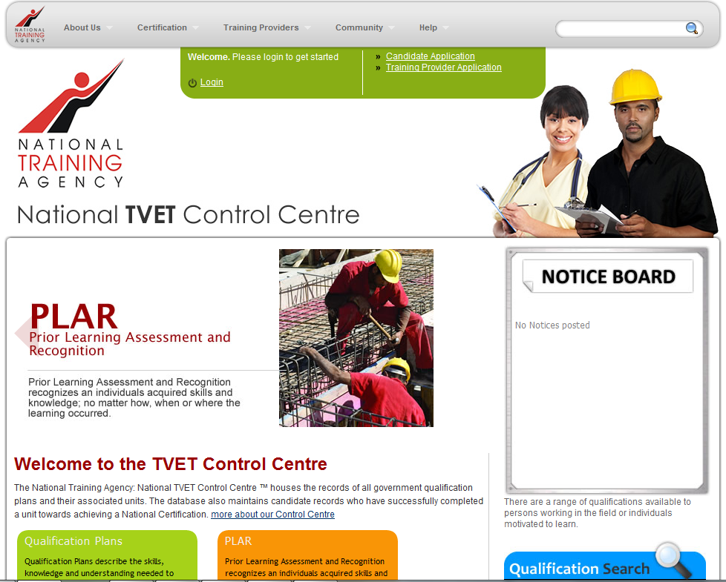
Figure 1
To log in, the user will be required to click the Login navigation link at the top of the screen (see Figure 1). The user will then fill out the fields provided by entering their User Name and Password. Next, click the Login button below the field or simply press the Enter key on the keyboard (see Figure 2).
Figure 2 User Login

The User Name for a Registered Training Provider (RTP) account usually has the format RTP9999 or RTP9999-USR9999.

On first login, you may be required to change your password to ensure greater security. Please enter your old password [received in the email] and enter the new password [both in the new password and confirm new password fields].

User Access Level
The system is designed to facilitate users with varying user functions and roles. The same login screen is applicable to all users to enter but based on their login credentials, access to specific system features which will granted or denied.

Changing Password
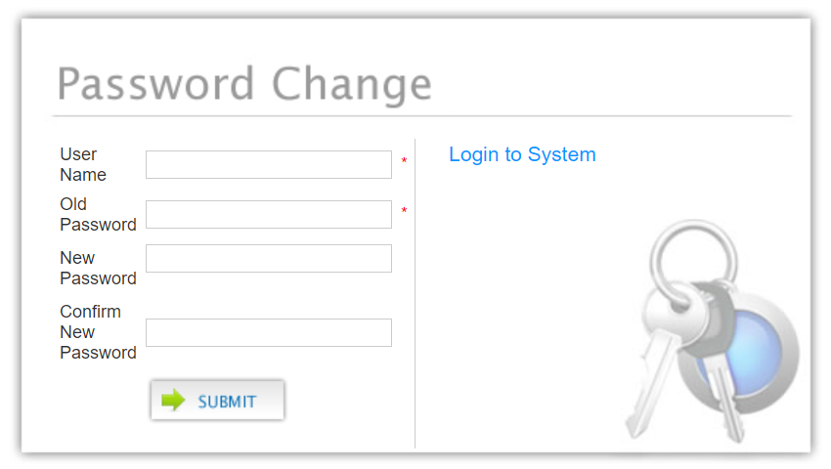
To change or update a password, click the Change My Password link from the login screen or Change Password on the Training Provider Main Panel. The user will provide their user name, the current password, create a new password and then re-enter it for confirmation. Click the Submit button to record the password changes (see Figure 3).
Figure 3 Change Password

Password Recovery
If the password is forgotten, click the Forgot my Password? link. The user provides the correct user name and submit. A new password will be generated for the user and sent to the email address saved for the user.

Logging out
It is imperative for users to log out after completing their intended task. This is even more necessary for systems which have multiple users.
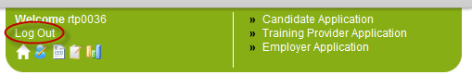
Figure 4 Log out

To log off the TVETCC, click the Log Out button (as highlighted on the image above).

Using The Training Provider Main Panel
The first screen which comes up after login gives the training provider quick links to resources which would be most utilized by a training provider (see Figure 5).
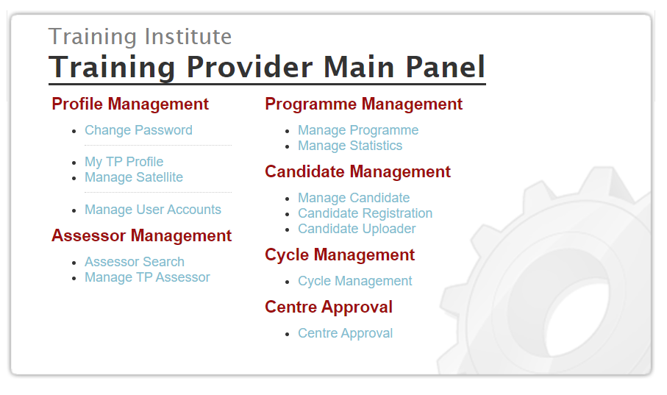
Figure 5 Training Provider Main Panel

At any time, users can click the “My Portal” link on the top of any screen to return to the Training Provider Main Panel.

As seen in Figure 5, the control panel gives the training provider quick access to the following functions:
Profile Management  - Changing password  - Managing training provider profile  - Managing satellite centres  - Managing user accounts  Assessor Management  - Searching for assessors  - Managing associated assessors | Programme Management  - Managing Programmes  - Managing Statistics  Candidate Management  - Manage Candidates  - Creating new candidate accounts  - Upload candidate list  Cycle Management  Centre Approval

Profile Management

Manage Profile
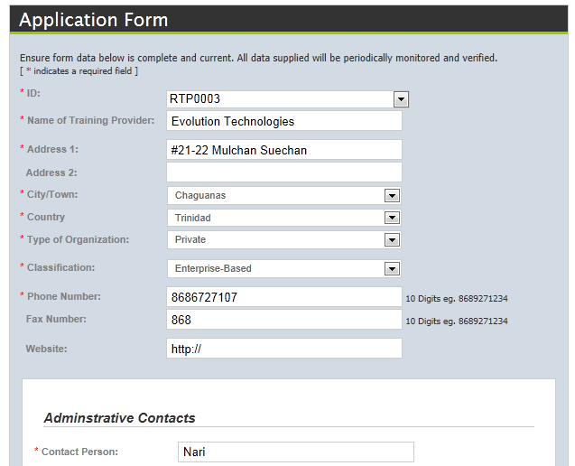
Training Providers are allowed to view and update their profile information by following the My TP Profile link (see Figure 5). The page that is provided is very similar to the TP registration page and is pre-populated with the information provided at registration. After making modifications, the training provider must press the Save button to update the saved record.

If a training provider has satellite centres, it’ll be displayed in the ID field drop down menu. Selecting a sub-centre from the drop-down menu, with display all of the associated information for the satellite.

Manage Satellite
Satellites are additional training centres (or sites) that operate under the main training provider. To access, click the link Manage Satellite from the Training Provider Main panel (Figure 5 Training Provider Main PanelFigure 5)

Viewing the List of Satellite Centre(s)
To view the list of the Satellite Centre(s), the user can enter search parameters, if any, to refine list and then click the Search button. Each satellite centre to be updated by clicking the Edit button and removed by clicking the Delete button.

Creating Satellite Centre
To create a Satellite Centre, the training provider can click the link Manage Satellite from the Training Provider Main Panel (see Figure 5 Training Provider Main PanelFigure 5) and then from the Manage Satellite Centres screen, click the Add a New Satellite Centre link highlighted in Figure 6
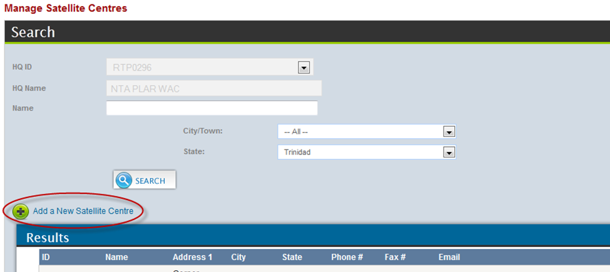
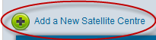
Figure 6 Manage Satellite Centre
This page is pre-populated with information from the main training provider profile. After completing the form click the Create button to save the information. Please note mandatory fields are identified by a red asterisk (*).
A notification dialog box pops-up indicating that the Satellite Centre was successfully created. Click OK.

User Accounts Management
Training providers can create user accounts to give staff limited or full access to the TVETCC in order to perform actions on behalf of the training provider.
To access, click the link Manage User Accounts from the Training Provider Main panel (Figure 5)
Viewing the List of User Account(s)
To view the list of the user account(s), the user can enter search parameters, if any, to refine list, and then click the Search button. Each user account to be updated by clicking the Edit button and removed by clicking the Delete button.

Creating User Account
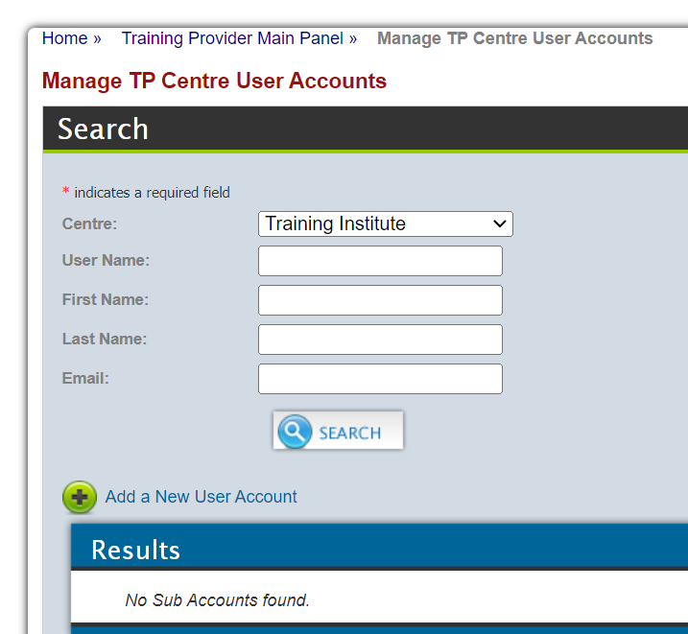
To create a Satellite Centre, the training provider can click on the link the link Manage User Account from the Training Provider Main panel (see Figure 5) and then from the Manage TP Centre User Accounts screen, click the Add a New User Account link highlighted in Figure 7.
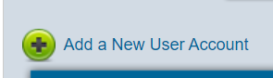
Figure 7 7Manage TP Centre User Accounts
The user would be taken to a page where all the relevant information needed to create a new TP User can be entered.
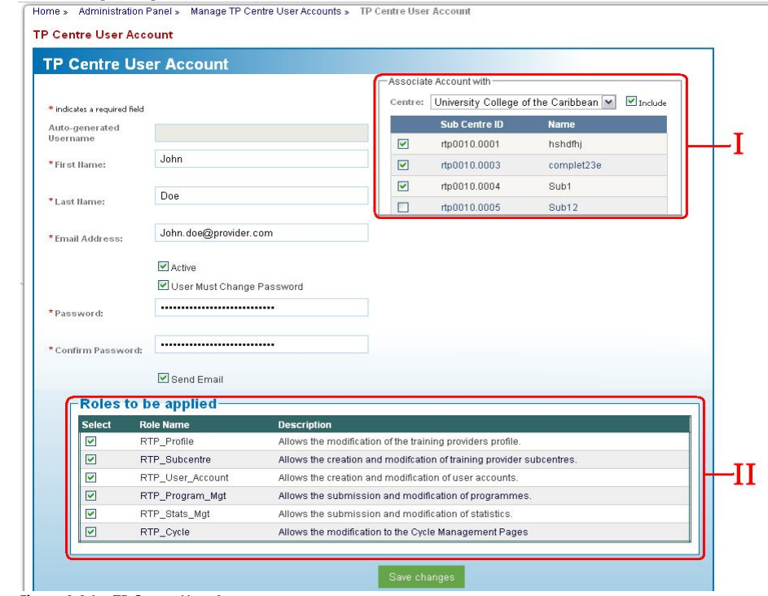
Figure 8 Create TP Centre User Account
II – This is a list of the roles for which the user being created is granted access to carry out.

I – This area has the main training provider and satellites, if any, for which the user being created performs roles or actions.

Creating the user
- Simply fill out the name, email and password on the form,
- Select the appropriate training provider and/or satellite centre(s) for which the user can perform actions on behalf of, from area I
- Select the roles which the user can carry out from area II.
- Then click Save Changes button.

Assessor Management

Assessor Search
To view the list of Assessors registered on the TVETCC, click the link Assessor Search from the Training Provider Main panel (Figure 5).
This page displays the assessors who are capable of awarding units/qualifications based on the search selected. If the search type is Qualification Plan the dropdown list becomes populated with assessors associated to the selected qualification plan. If the search type is Unit, then the dropdown becomes populated with assessors capable of delivering the selected unit.
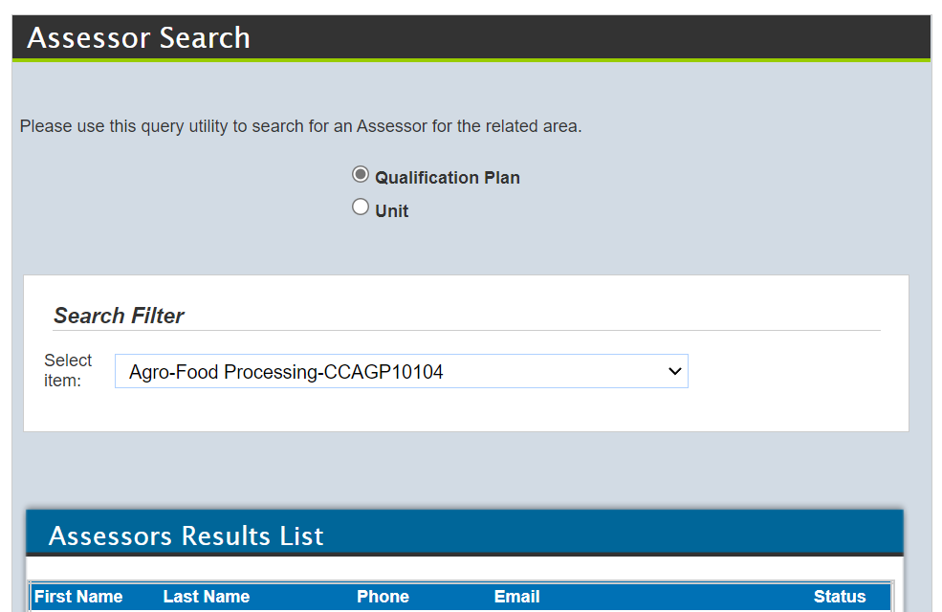
Figure 9 Assessor Search

Manage TP Assessor
Training Providers must list the assessors associated with their institution who would be performing the roles of assessor and internal verifier for their candidates. To access click the link Manage TP Assessor from the Training Provider Main panel (Figure 5).

Viewing list of Assessors associated to RTP/Satellite
To view the list of the assessors associated to RTP and / or Satellite centre, the user can enter search parameters, if any, to refine list, and then click the Search button.
The Clear button clears the current search paraments entered.

Deleting Training Provider – Assessor association
From the search results, users can remove any association that is no longer relevant by clicking the Delete button and then confirming it

This deletion only removes the association that is the assessor or Internal Verifier is no longer available to the RTP to include in the training cycle. This does not remove the assessor from the registered list of assessors.

Creating Training Provider – Assessor association
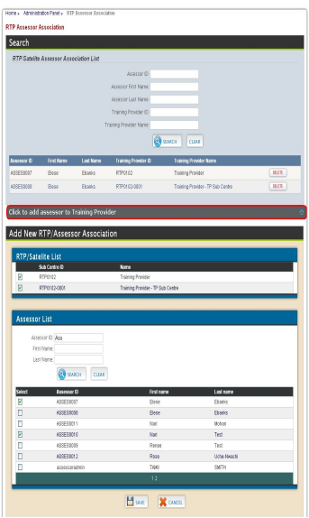  Figure 10 RTP Assessor Association | From this page (Figure 10), click the Click to add assessor to Training Provider bar. This reveals an area below.  The revealed area has two lists. The first being RTP/Satellite and the other being the list of registered assessors on the TVETCC.  Users can select the check box(es) for the applicable RTP and/ or satellite centres, then search and select the check box(es) for the relevant assessors and internal verifiers  Click the Save button to make the association.

Assessors can be associated to more than one training centre

Programme Management

Manage Programme
The training provider may wish to add their course offerings (not CVQ or TTNVQ approved) to the list of available courses in which the public can search. To access click the link Manage Programmes from the Training Provider Main Panel (Figure 5).

Viewing the List of Programmes associated to RTP/Satellite
To view the list of the associated programmes, the user can select the RTP or the Satellite centre.
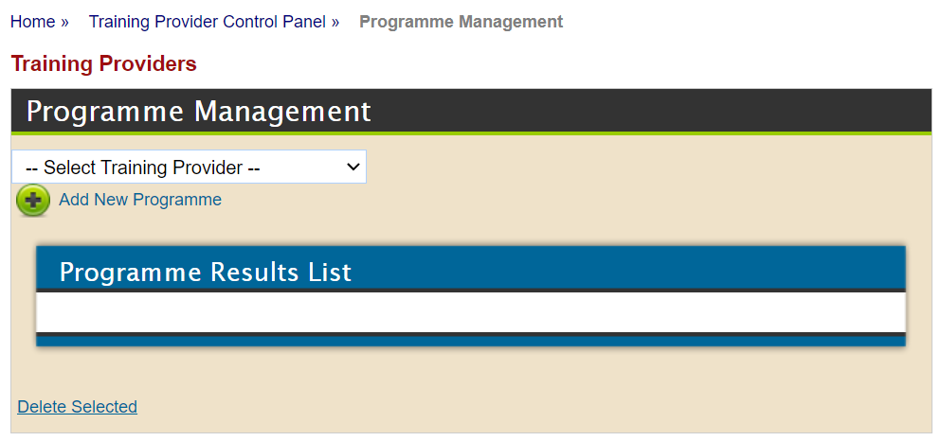
Figure 11 Programme Management

Editing Programme Submission
First, view the list of TP Programme Submissions. From the list, TP can then click the EDIT button next to the relevant programme to view and update its details and then save it.

Deleting Programme Submission
First, view the list of TP Programme Submissions. From the list of TP Programme Submissions, the TP can click the DELETE button and confirm the deletion of the selected Programme Submission.

Creating TP Programme Submission
From this page (Figure 11), click the Add New Programme link which opens a new screen. Enter the appropriate information and click the Submit Now button to save.
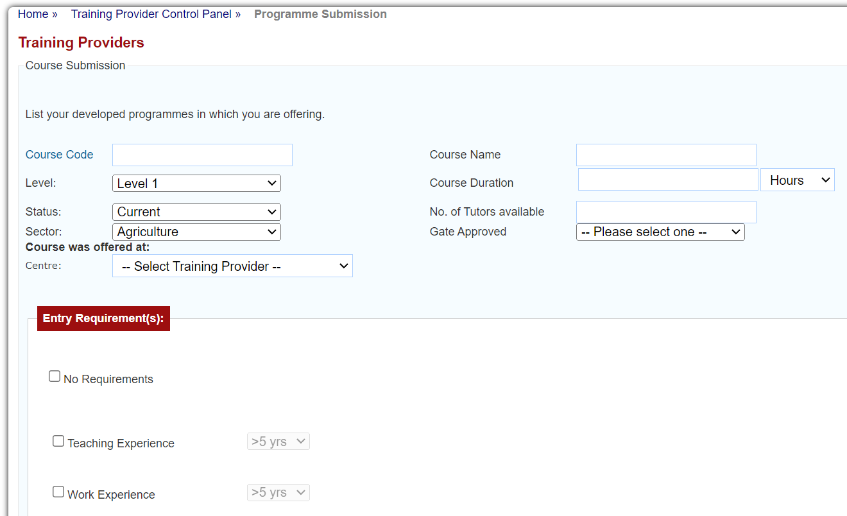
Figure 12 Programme Submission

Statistic Management
Statistic management allows the training provider to keep track of the enrolment and graduation tallies of candidates from each programme and cycle. To access click the link Manage Statistics from the Training Provider Main panel (Figure 5).

Viewing the List of Statistics Submitted
To view the list of statistics submitted for a RTP or Satellite centre, the user can enter search parameters, if any, to refine list, and then click the Search button
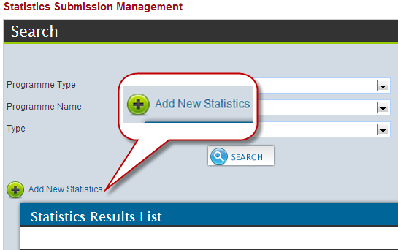
Figure 13 Statistics Management

Adding New Statistics
From this page (Figure 13), click the Add New Statistics link which opens a new screen. Enter the appropriate information and click the Submit button to save.

Candidate Management
Candidate management allows the training provider to create and update candidate accounts for their students/ trainees /learners.

Manage Candidate
Training providers can view and update information on existing candidates accounts. To access click the link Manage Candidate from the Training Provider Main panel (Figure 5).
To view information on a candidate, the user can enter the candidate’s user ID or name and any other necessary search parameters to refine list, and then click the Search button.
The Clear button clears the current search paraments entered.
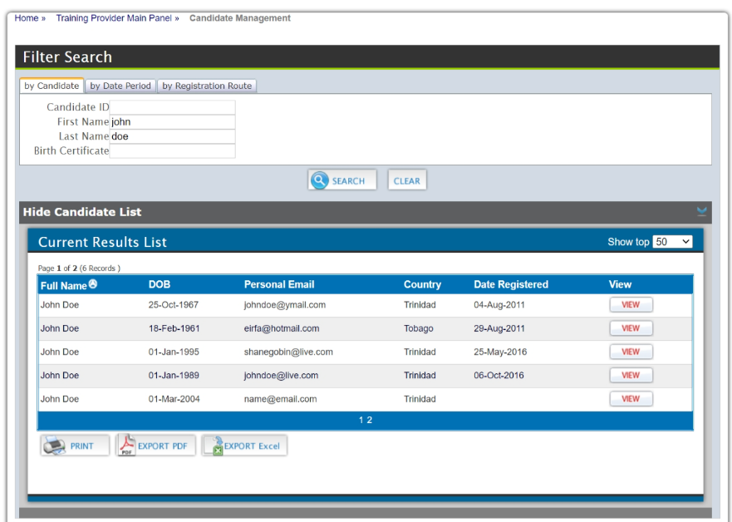
From the list of candidates that satisfy the search parameters, click the View button next to the selected candidate. This will populate the area below the list with the personal information on the selected candidate.
Figure 14 Manage Candidate
It is recommended to search for an existing account for a candidate before creating a new candidate account to avoid duplication.

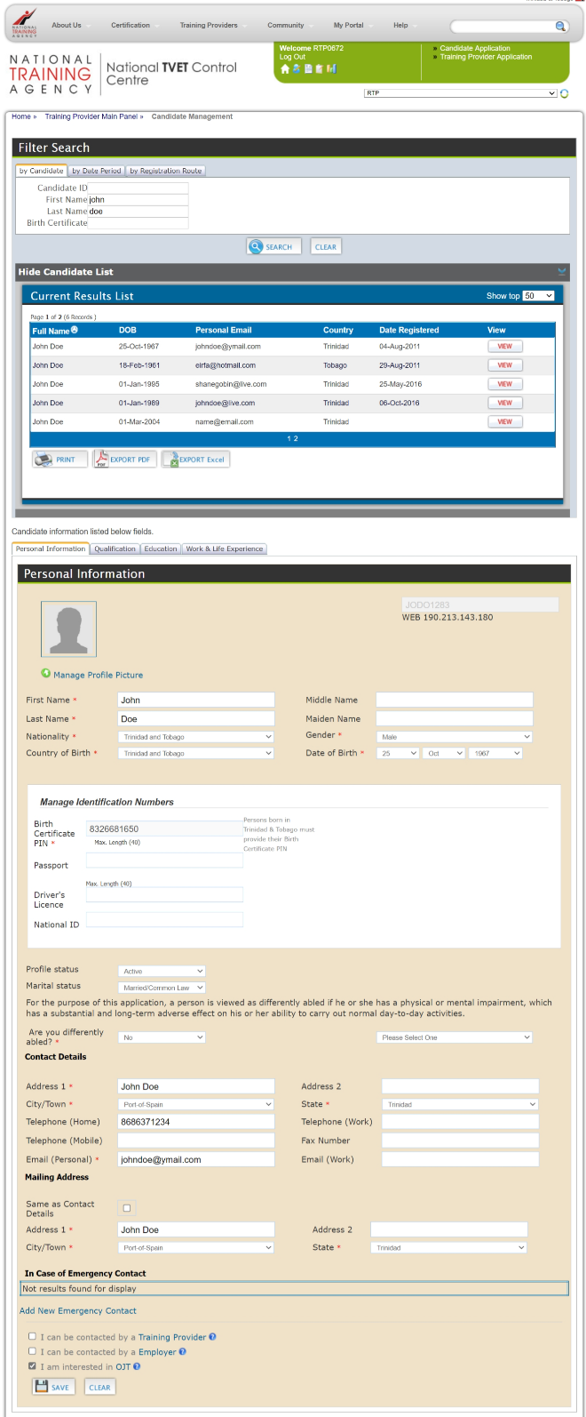  Figure 15 Candidate Summary | Some information can be edited e.g., the candidate’s name, address. The training provider can update the fields with the correct information and then click the Save button.  The training provider can also view TTNVQs/ CVQs awarded to the candidate by switching to the Qualification tab.  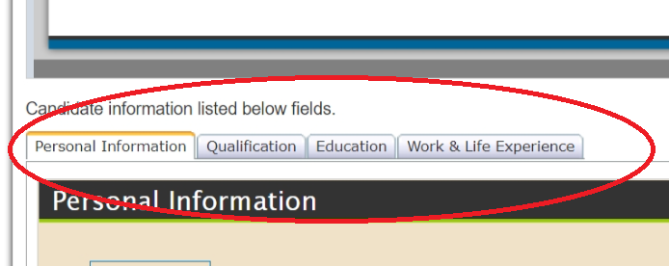  The Education tab displays any details, entered by the candidate, relating to their educational history.  The Work and Life Experience tab displays any details, entered by the candidate, relating to their work history.

Candidate Registration
Training providers can create candidate accounts by registering their students/ trainees /learners if they do not have an existing account on the TVETCC. To access click the link Candidate Registration from the Training Provider Main panel (Figure 5).
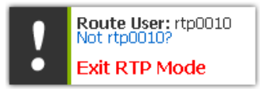
The Route User identifies the user that entered the information in case of any further clarification that may be needed. To change the user, click the icon and enter the correct login information in the fields which become available.
The user can then complete the form with the relevant information click the Save button. Please note the following
- Fields identified with a red asterisk (*) must be filled out.
- If Trinidad and Tobago is selected as the country of birth, the Birth Certificate Pin field is mandatory, Otherwise, the Passport Number becomes the mandatory field.
- The City/Town list changes when the State field switches between Trinidad and Tobago.
- Once the candidate registration is successful, the candidate’s unique ID and password is displayed. Please copy this information and share with the candidate. This information would also be sent to the given email address of the candidate.
.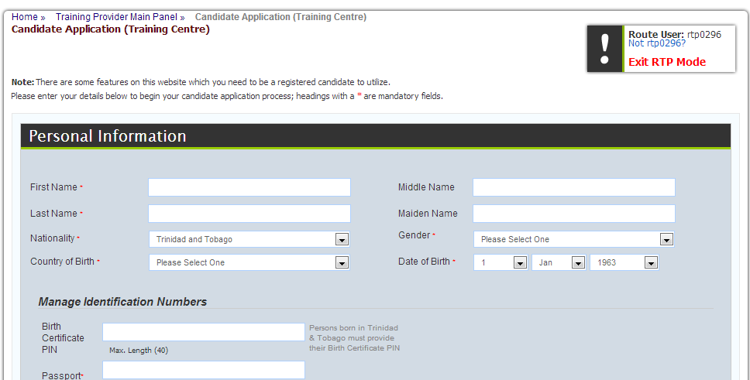
Figure 16 Candidate Registration
To create another candidate account, click the Register another Candidate button.

Candidate Uploader
The Candidate Uploader function is intended to facilitate those training providers with a separate candidate management system. This allows the user to upload exported candidate data (from existing candidate management system) into the TVETCC.
There must be strict adherence to the following rules to produce the desired results.
Rules for Creating Candidate Upload File
- The candidate data must be saved in an Excel 2003 document (.XLS).
- The file should consist of twenty-two (22) data columns with the first row being the header column and the remaining rows the data rows. See table for the column definitions below for rules and restrictions. Any deviation would affect import.
- If the Country of Birth is Trinidad and Tobago, a Birth Certificate Pin must be entered else enter a Passport Number in the respective field.
- Close attention to be paid to notification messages after the upload is completed
Column Definition Table
Column Name | Required | Data Type | Description | Restrictions
First Name | Yes | 100 Characters | Candidate First Name
Middle Name | No | 100 Characters | Candidate Middle Name
Surname | Yes | 100 Characters | Candidate Last Name
Maiden | No | 100 Characters | Candidate Maiden Name
Nationality | Yes | 40 Characters | Nationality of Candidate | Data must be entered as one of the options from the Nationality drop-down list as seen on page http://www.ntatvetcentre.org/register.aspx
Gender | Yes | 6 Characters | Candidate’s Gender | Data must be entered as Male, Female, M, or F
Country of Birth | Yes | 40 Characters | Country of Birth | Data must be entered as one of the options from the Country of Birth drop-down list as seen on page http://www.ntatvetcentre.org/register.aspx
Birthday | Yes | Numeric | Day of Birth
BirthMonth | Yes | Numeric | Month of Birth
BirthYear | Yes | Numeric | Year of Birth
Birth Cert Pin | No * | 40 Characters | Birth Certificate PIN
Passport | No * | 40 Characters | Passport
Driver’s Licence | No | 40 Characters
National ID | No | 40 Characters
Marital Status | Yes | 10 Characters |  | Data must be entered as Single, Married, Common-Law, Widowed, Divorced, S, M, C, W, D
Differently Abled | Yes | 3 Characters |  | Data must be entered as Yes, No, Y, N
Address 1 | Yes | 90 Characters | Street
Address 2 | Yes | 40 Characters
Address 3 | Yes | 40 Characters | City | Data must be entered as one of the options from the City drop-down list as seen on page http://www.ntatvetcentre.org/register.aspx
Telephone | No | 10 Characters
Cell | No | 10 Characters
Email | Yes | 75 Characters

Uploading Candidate Data
- The Excel spreadsheet should be already created in accordance to above given rules and restrictions
- To access click the link Candidate Uploader from the Training Provider Main panel (Figure 5).
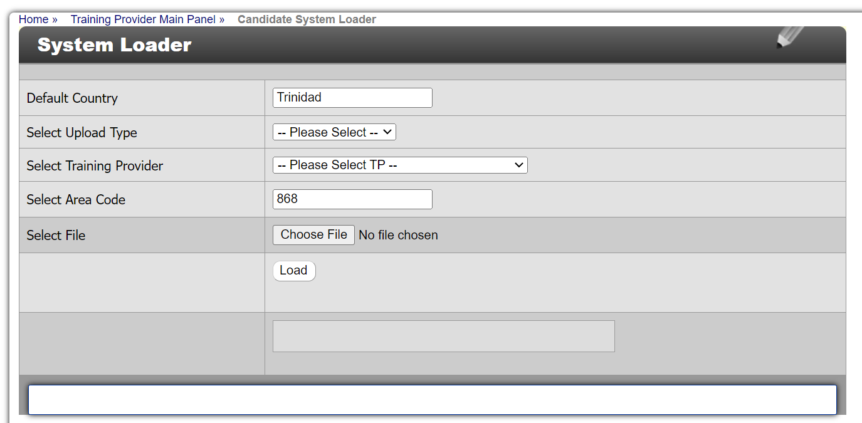
Figure 17 Candidate Uploader
- Change the default country, if necessary. The Default country would be used if an invalid country is found in the Excel uploader
- Select Candidate Data as the Upload Type
- Select the appropriate Training Provider
- Change the Area Code if necessary. This would be used as the default area code for Telephone and Cell Fields if the data length is less than 8 characters
- Click the Choose File button to locate the Excel Template on the user’s storage.
- Click the ‘Load’ Button to begin uploading the Candidate file.
Please note that the other following defaults if invalid data is entered in Excel uploader file
Field | Default Value
Marital Status | Single
Differently Abled | No
Address3 | Port-Of-Spain

A log message is shown at the end of the processing to indicate success and failure messages.

Cycle Management
Cycle Management allows the Training Providers to specify and manage the beginning and end of a training period and qualifications assigned through cycles on the TVETCC. This module also allows for the enrolment of candidates and the inclusion of the assessors and internal verifiers. To access click the link Cycle Management from the Training Provider Main panel (Figure 5). This will redirect the user to the Cycle Management panel (see Figure 18Error! Reference source not found.).

Figure 18 Cycle Management Panel

Viewing the List of Cycles
To view the list of cycles submitted for a RTP or Satellite centre, the user can click on the link Manage Cycle (Figure 18). This redirects the user to the Cycle Management screen (see Figure 19). Then enter search parameters, if any, to refine list, and then click the Search button.

Updating an Existing Cycle
First, view the list of cycles. From the list, the user can click the EDIT button for the relevant cycle and modify the cycle as needed, add or remove qualification plans and then click the SAVE button to commit changes.
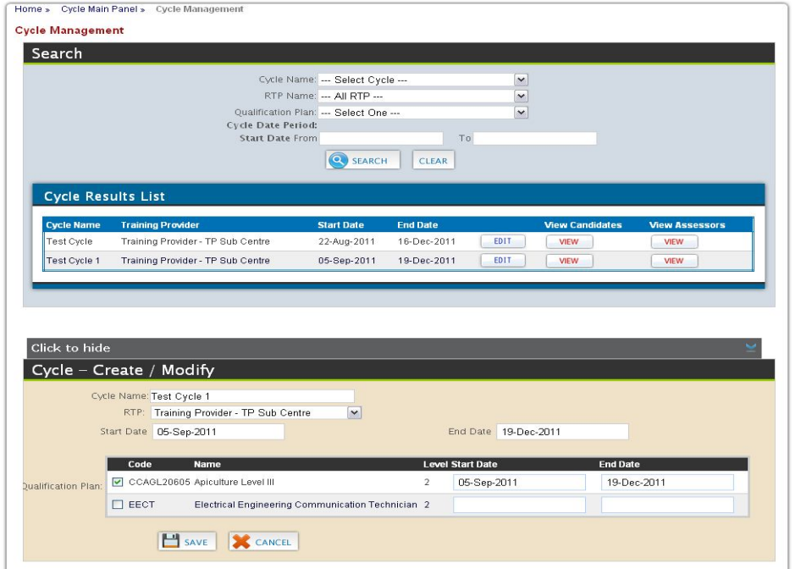
Figure 19 Editing or Creating New Cycle

Creating a Cycle
- To create a cycle, click the Click to Add Cycle bar.
- Complete the fields under the Cycle – Create/Modify section.
  - Cycle Name – Unique name to identify the cycle created.
  - RTP – The RTP or satellite centre for the cycle
  - Start Date – Start date of the cycle
  - End Date – End date of the cycle
  - Qualification Plan- available qualification plans for the RTP/ satellite centre
- Click the Create button. Once successful created, the new cycle would be displayed in the section above.

Assessor Cycle Management
Training providers need to identify all the Assessor(s) and Internal Verifier(s) for each created cycle. To access this section, click the View button under the View Assessors column, for the relevant cycle from the list of existing cycles (see Figure 19).
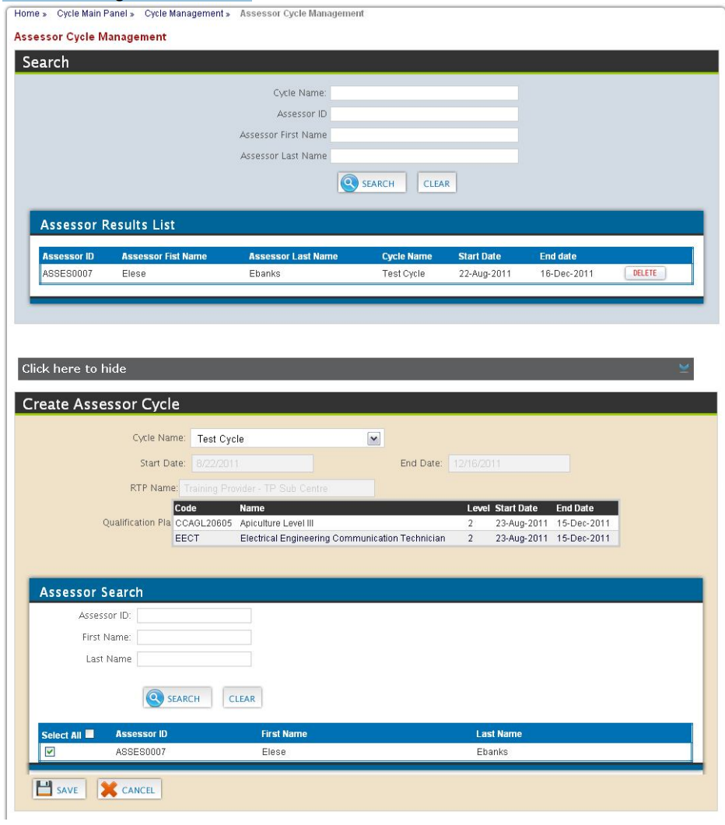
Figure 20 Assessor Cycle Management

Viewing List of Assessor Associated to Cycle
To view the list of assessors and internal verifiers already associated to the cycle, enter search parameters, if any, to refine list, and then click the Search button (see Figure 20).

Deleting Assessor Cycle Association
First, view the assessors associated to the cycle. From the list, click the DELETE button to remove the relevant association from the list.

Creating Assessor Cycle Association
To associate an assessor or internal verifier to a cycle, click the Click to add assessor to cycle bar. The information for the selected cycle will appear. Then select the relevant assessors by clicking the checkbox and click the SAVE button to record the association.

If the necessary assessor is not available to be selected, please verify that the assessor is associated to the RTP and the qualification plan for the cycle.

Enrol Candidates into Cycle
Training providers need to identify the candidate(s) for each created cycle. To access this section, click the View button under the View Candidates column, for the relevant cycle from the list of existing cycles (see Figure 19).

Viewing List of Candidates Associated to Cycle
To view the list of candidates already associated to the cycle, enter search parameters, if any, to refine list, and then click the Search button (see Figure 21).

Editing a Candidate – Cycle Association
First, view the list of candidates in the cycle. From the list, click the EDIT button for the relevant candidate. The user would then be able to change the assessor assigned to facilitate the cycle.

Deleting Candidate – Cycle Association
First, view the list of candidates in the cycle. From the list, click the DELETE button for the relevant candidate to remove the association from the list.
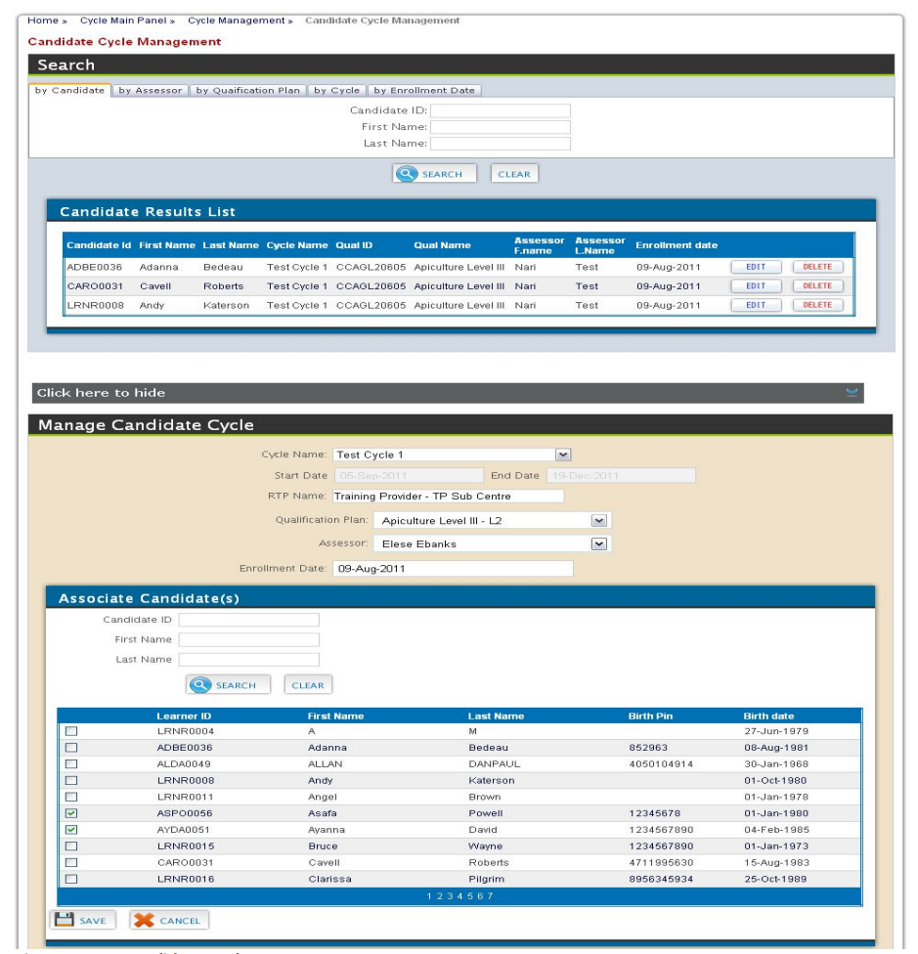
Figure 21 Candidate Cycle Management

Creating Candidate – Cycle Association
To associate a candidate to a cycle,
- Click the Click to add candidate to cycle bar. The information for the selected cycle will appear.
- Select the relevant Qualification Plan (dropdown shows list of qualification plans associated to the cycle)
- Select the relevant Assessor (dropdown shows list of assessors associated to the cycle).
- The enrollment date can be adjusted as necessary.
- Search the list of registered active candidates by entering Candidate ID (or First name or Last name) and clicking the Search button. Select the candidates by clicking on the checkbox next to the appropriate candidate.
- Click the SAVE button to complete the association

Multiple candidates can be searched for and selected before clicking the SAVE button

Centre Approval
Training providers that are interested in offering training and/ or assessment, leading to a TTNVQ or CVQ must seek approval from the NTA. To access click the link Centre Approval from the Training Provider Main panel (Figure 5).

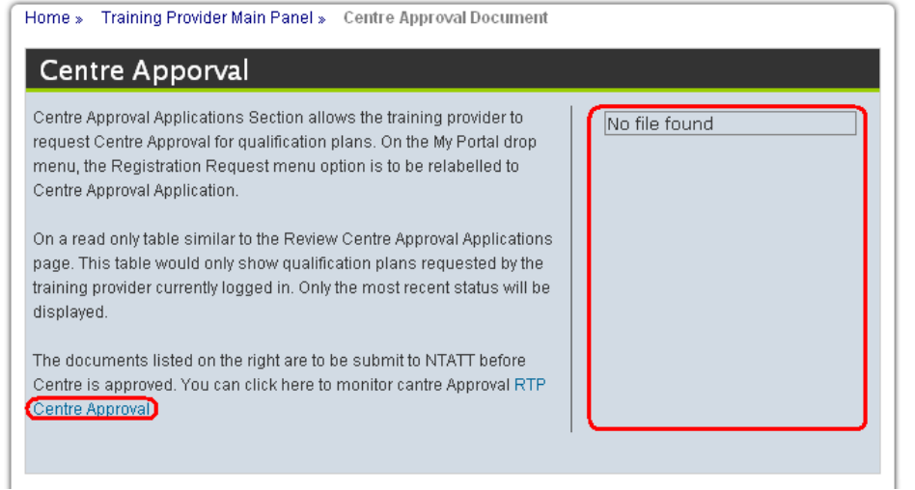
Figure 22 Centre Approval Panel

The panel to the right lists the documents required by NTA for centre approval, which are available for download. Training providers can then complete and submit to the relevant NTA officers.

Centre Approval Management
The training provider would be able to indicate interest in a particular TTNVQ or CVQ as well track its approval. To access click the link RTP Centre Approval from the Centre Approval panel (Figure 22)

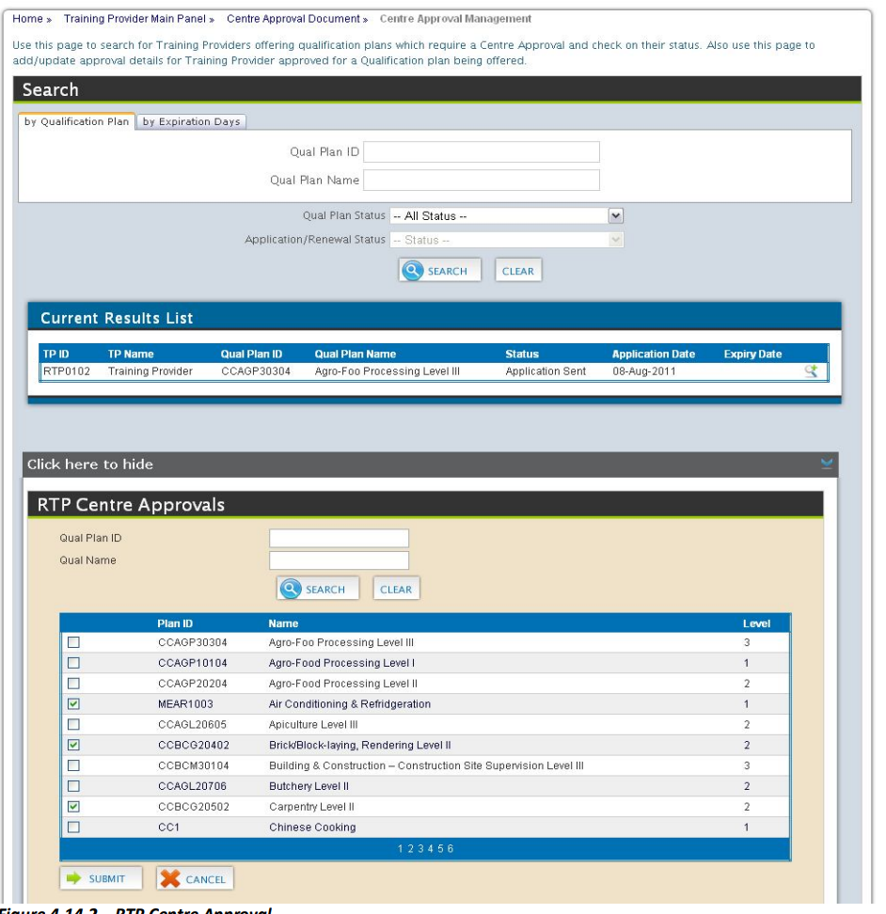
Figure 23 Centre Approval

Viewing list of Approvals being processed
To view the list of approvals being processed, enter search parameters, if any, to refine list, and then click the Search button.
Please note that the options under the filter Qual Plan Status are:
- Processing - This enables the Application/Renewal Status, allowing further refinement of the search result by one of statuses listed in the dropdown.
- Archive – History of Qual Plan centre Approval
- Compliant – Approved Qual Plans which are not expired
- Expired – Qual Plans for which the date of expiry has elapsed

Viewing Application Comment
To view comments on the application, the user can click the icon to the right of the item in the result list. This will reveal the comments in the area immediately below. This section can be closed by clicking the close button  below the list of comments.

Applying for Approval to offer a TTNVQ or CVQ
Click the Click here to enter Audit Information bar to expand page content. Search for the relevant the qualification plan by Plan ID or name. Tick the appropriate check box in the search results and click the SUBMIT button.

Renewing Approval to offer a TTNVQ or CVQ
Click the Click here to enter Audit Information bar to expand page content. Search for the relevant the qualification plan by Plan ID or name. Tick the appropriate check box in the search results and click the SUBMIT button.

Step-by-Step Guide for Training Providers
This section is meant to assist training providers to ensure the steps necessary towards the certification of their candidates on the TVETCC. The following are the necessary major steps:

Error Handling

Common Errors
Error | Possible Cause | Solution
Unable to login | Password is either incorrect or expired. | If forgotten, try Forgot my Password? Link (see page 6)  else send email requesting password reset
Unable to see required assessors when adding to the cycle. | The cycle does not have the required qualification selected. | Ensure relevant qualifications are selected for cycle (see page 24)
Unable to see required assessors when adding to the cycle. | Assessors not associated to relevant qualification | Check list of assessors attached to the relevant qualification (see page 12)
Unable to see required assessors when adding to the cycle. | Assessors not associated to Training Providers | Check list of assessors attached to the training provider (see page 13)

Help Facilities
Our technical support team is ready to answer questions that may arise or provide technical assistance in dealing with any issue(s) that may arise. Feel free to contact any of the following members of our support team
- Michelle Ghatt Deane, TVETCC, Senior Coordinator (michelle-ghatt@ntatt.org)
- Nari Mohan, Systems Analysts
- Rose Uche-Nawachi, Database Administrator
Email : tvetcc-support@ntatt.org

Appendix A - Glossary
Term | Definition
Assessor | A certified person authorized by an organisation to judge the performance of candidates against the occupational standards.
Candidates | An inclusive term referring to anyone learning, including students, apprentices, learners, interns; trainees, and people learning non-formally and informally as well as people enrolled for particular qualifications or part qualifications.
Centre Approval Process | The process that a centre must undergo to be granted permission by the Awarding Body to register and assess candidates for TTNVQs or CVQs
Certification | This is the process by which an approved centre requests, and the Awarding Body provides, a certificate for each candidate on completion of:  ♦ the entire set of units required for the award of the CVQ  ♦ one or more units of an CVQ (for those candidates not enrolled for a full CVQ
CVQ | The Caribbean Vocational Qualification (CVQ) is an award that represents achievement of a set of competencies which define core work practices of an Occupational area, consistent with the levels articulated within the regional qualifications’ framework. To earn an award, candidates must demonstrate competence in reaching CARICOM-approved occupational standards developed by practitioners and employers (i.e., the industry experts). These standards are organized in units. Candidates may earn unit awards towards achieving a complete CVQ.
Cycle | The time period stipulated for the delivery of training.
External Verifier | An External Verifier is an individual contracted by the Awarding Body to carry out a Quality Assurance Audit of the CVQ provision in an approved Centre to ensure that centres approved to offer CVQs are consistently judging candidates equally, fairly and in accordance with the regional occupational standards.
Internal Verifier | A person nominated by an approved centre who is responsible for internal quality assurance, mainly through assuring the quality and consistency of assessments by Assessor(s).
Satellite centre | Additional training centres (or sites) operating in a different location from the main training provider
Training Provider | An institute, enterprise or community-based organisation which provides training and/or facilitates the training process for the acquisition of competences in keeping with occupational and national standards, accredited facilities and vocational qualifications, and appropriate resources
TVET | Technical and vocational education and training’ (TVET) is understood as comprising education, training and skills development relating to a wide range of occupational fields, production, services and livelihoods.  TVET, as part of lifelong learning, can take place at secondary, post-secondary and tertiary levels and includes work-based learning and continuing training and professional development which may lead to qualifications. TVET also includes a wide range of skills development opportunities attuned to national and local contexts. Learning to learn, the development of literacy and numeracy skills, transversal skills and citizenship skills are integral components of TVET.  Source: UNESCO (GC) 2015, UN
Unit | Units are a set of learning outcomes (knowledge, skills, and attitude) which constitute a coherent part of a qualification. A unit can be the smallest part of a qualification that can be assessed, transferred, validated and, certified. A unit can be specific to a single qualification or common to several qualifications.

