National Training Agency
Version 2.0



[TVET Control Centre User Manual – Assessor Management]
To assist persons with the role of Assessor and Verifiers in navigating the functions of the TVETCC.

Revision History

Version | Date | Revision Description | Last Edited by
1.0 | 04 Jan 2013 | Initial release | Nari Mohan
2.0 | Apr 2022 | Content and layout updated | MGD

Table of Contents
1.1.1. Revision History ii
1. Introduction 1
1.1. Purpose 1
1.2. Intended Audience 1
1.3. Acronyms and Abbreviations 2
2. Application Overview for Assessors 3
2.1. Organization of Manual 3
2.2. Reference to other manuals 3
3. Getting Started 4
3.1. Accessing the TVET Control Centre 4
3.2. User Login Credentials 4
3.3. User Access Level 5
3.4. Changing Password 6
3.4.1. Password Recovery 6
3.5. Logging out 6
4. Using The Assessor Main Panel 7
4.1. Profile Management 8
4.1.1. My Assessor Profile 8
4.2. Assessor Management 9
4.2.1. Assessor Search 9
4.2.2. Assessor Notice Board 10
4.3. Certificate Management 11
4.3.1. Candidate Profiles 11
4.3.2. Enrol Candidates into Cycle 13
4.3.3. Managing Candidates’ units 14
4.3.4. Awarding units to candidates via PLAR 17
4.3.5. Managing Cycle 18
4.3.6. Managing PLAR 19
5. Step-by-Step Guide for Assessors 23
6. Error Handling 24
6.1. Common Errors 24
6.2. Help Facilities 24
7. Appendix A - Glossary 25

Introduction
The national TVET Control Centre (TVETCC) is a secure online database solution designed to collect and store information, within the TVET System, on:
- TVET Training Providers that are Enterprise, Community, Institution and School based
- Training Programs
- Trainers/Assessors
- Trainees/Graduates.
The TVETCC facilitates the interaction of stakeholders involved in the certification process towards the Trinidad and Tobago National Vocational Qualifications (TTNVQs) or Caribbean Vocational Qualifications (CVQs).
Stakeholders include the candidates, training providers’ administration, assessors, verifiers and the staff of the National Training Agency (NTA).

Purpose
The purpose of this manual is to provide all the necessary information to navigate the TVETCC as an assessor, internal verifier, or an external verifier. The manual assumes that the user has a good knowledge of the certification process.

Intended Audience
This manual is intended for persons performing the role of the unit verification such the assessors, internal verifiers, and the external verifiers.

Acronyms and Abbreviations
CVQ | Caribbean Vocational Qualification
NTA | National Training Agency
PLAR | Prior Learning Assessment and Recognition
RTP | Registered Training Provider
TTNVQ | Trinidad and Tobago National Vocational Qualification
TVET | Technical Vocational Education & Training
TVETCC | TVET Control Centre

Application Overview for Assessors
The role of the assessor on the TVETCC is to formally record the result of the assessment. The assessor account allows the assessor to:
- Manage the assessor profile
- Manage the candidates associated to the cycle
- View training cycles
- Award/verify units to candidates in the training cycles
To participate on the TVETCC as an internal verifier or external verifier, the assessor account would be used, with enhanced security roles. For the purposes of the TVETCC and this manual, the functionality of the assessor account applies to the roles of assessor, internal verifier and external verifier.

Organization of Manual

Reference to other manuals
Please see the TVET Control Centre User Manual – Training Provider Management for persons in the role of the Training Provider Administration.
Please see the TVET Control Centre User Manual – Candidate Management for candidates.

Getting Started

Accessing the TVET Control Centre
The TVET Control Centre is accessed via a web browser and is available on the World Wide Web. The url is www.ntatvetcentre.org .
The website is compatible with all major browsers: Google Chrome, Microsoft Edge, Mozilla Firefox, Safari, Netscape, Opera and Internet Explorer 6 and above. This is by no means an exhaustive list; there are smart phones and other hand-held devices which can also be used to gain access to the website technologies.
The General Public can browse the site, create searches and gather general information. Some features of the site are restricted to privileged user accounts.

User Login Credentials
User credentials refer to the paired username and password which is required to allow a user access to the website. The paired key is used to uniquely identify each user to the system. Users should make every effort to secure these keys to ensure that only authorized persons gain access and to prevent unwanted exploitation of the user’s account.
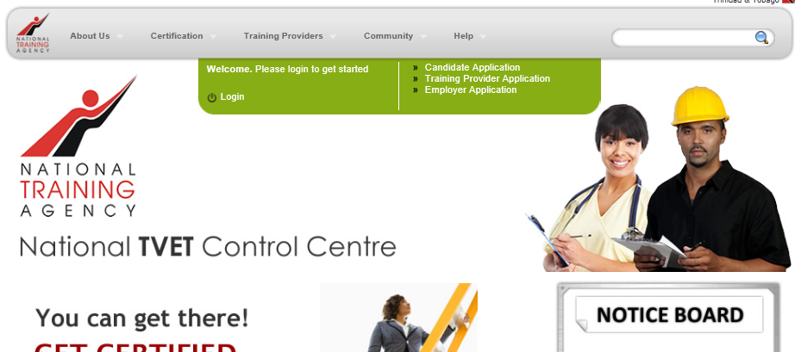
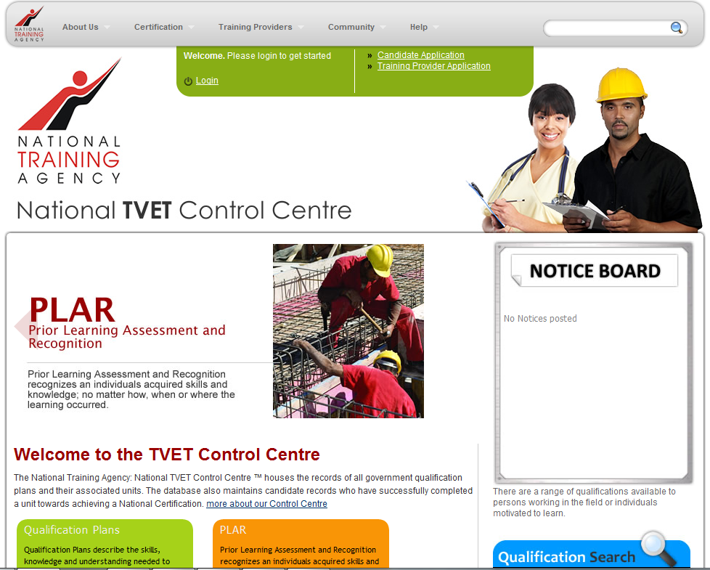
Figure 1
To log in, the user will be required to click the Login navigation link at the top of the screen (see Figure 1). The user will then fill out the fields provided by entering their User Name and Password. Next, click the Login button below the field or simply press the Enter key on the keyboard (see Figure 2).
Figure 2 User Login

The User Name for an Assessor, Internal verifier or External Verifier account usually has the format ASSES9999.

On first login, you may be required to change your password to ensure greater security. Please enter your old password [received in the email] and enter the new password [both in the new password and confirm new password fields].

User Access Level
The system is designed to facilitate users with varying user functions and roles. The same login screen is applicable to all users to enter but based on their login credentials, access to specific system features which will granted or denied.

Changing Password
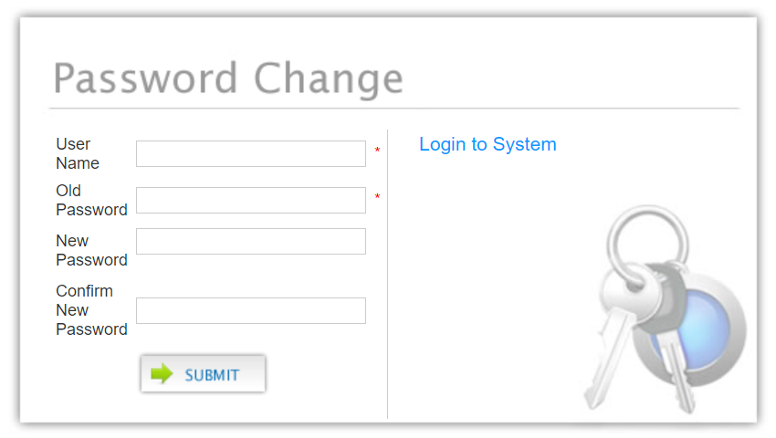
To change or update a password, click the Change My Password link from the login screen or Change Password on the Assessor Main Panel. The user will provide their user name, the current password, create a new password and then re-enter it for confirmation. Click the Submit button to record the password changes (see Figure 3).
Figure 3 Change Password

Password Recovery
If the password is forgotten, click the Forgot my Password? link. The user provides the correct user name and submit. A new password will be generated for the user and sent to the email address saved for the user.

Logging out
It is imperative for users to log out after completing their intended task. This is even more necessary for systems which have multiple users.

Figure 4 Log out

To log off the TVETCC, click the Log Out button (as highlighted on the image above).

Using The Assessor Main Panel
The first screen which comes up after login gives the Assessor quick links to resources which would be most utilized by an assessor/internal verifier/ external verifier (see Figure 5).
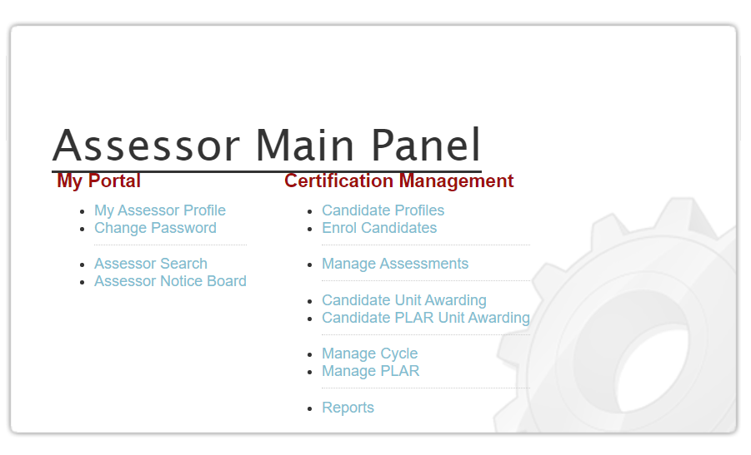
Figure 5 Assessor Main Panel

At any time, users can click the “My Portal” link on the top of any screen to return to the Assessor Main Panel.

As seen in Figure 5, the control panel gives the assessor quick access to the following functions:
Profile Management  - My Assessor Profile  - Changing password  Assessor Management  - Searching for assessors  - Assessor Notice Board | Certificate Management  - Managing Candidates profiles  - Enrolling candidates  - Awarding units to candidates  - Awarding units to candidates via PLAR  - Managing Cycle  - Managing PLAR  - reports

Profile Management

My Assessor Profile
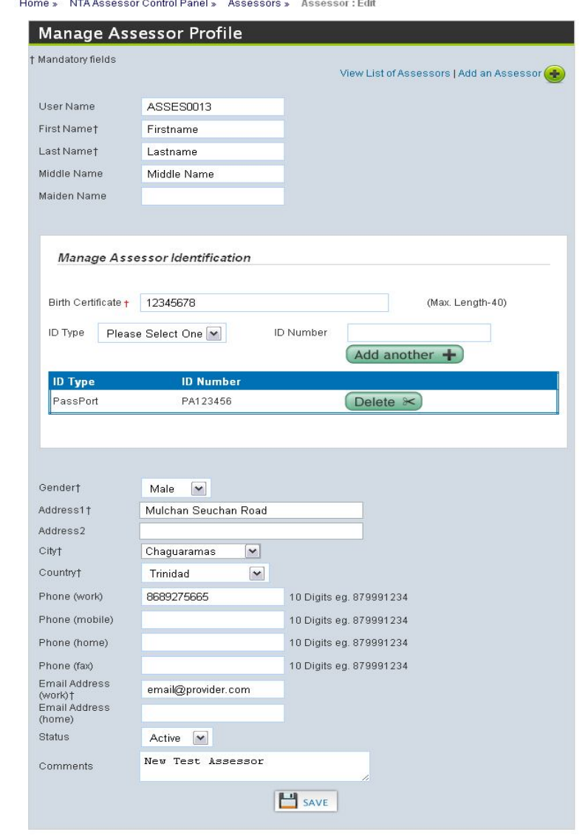
Assessors are allowed to view and update their profile information by following the My My Assessor Profile link (see Figure 5). The page provides the information that is on record at registration. After making modifications, the assessor must press the Save button to update the saved record.

For the purposes of the TVETCC and this manual, the functionality of assessor account applies to the roles of assessor, internal verifier and external verifier.

Assessor Management

Assessor Search
To view the list of Assessors registered on the TVETCC, click the link Assessor Search from the Assessor Main panel (Figure 5).
This page displays the assessors who are capable of awarding units/qualifications based on the search selected. If the search type is Qualification Plan the dropdown list becomes populated with assessors associated to the selected qualification plan. If the search type is Unit, then the dropdown becomes populated with assessors capable of delivering the selected unit.
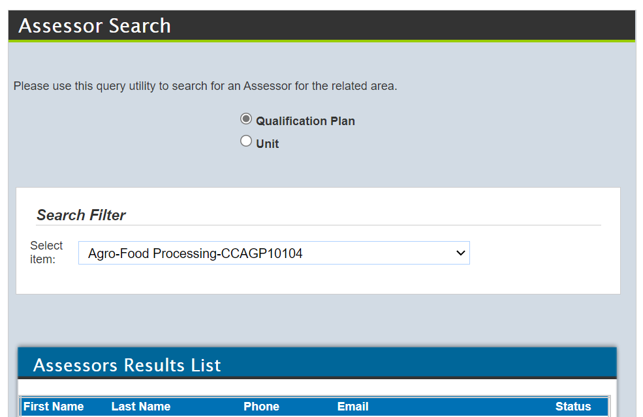
Figure 6 Assessor Search

Assessor Notice Board
The assessor notice board is a centralized area of the website where messages and events are posted to assessors. To view the posted notices, assessors can click the Assessor Notice Board link from the Assessor main Panel (see Figure 5 ) or place the mouse cursor over My Portal on the navigation bar at the top and select Notice Board from the dropdown menu.

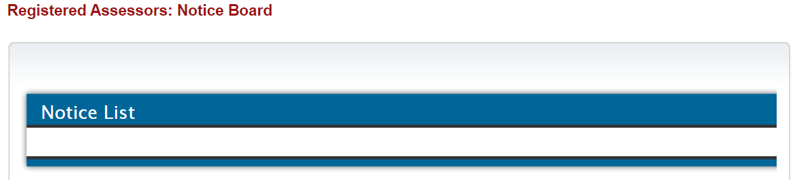
Figure 7 Assessor Notice Board

Certificate Management
Certificate management allows the assessor
- to create and update candidate accounts
- enrol candidates in cycles
- create and schedule online assessments
- award units

Candidate Profiles
Assessors can view and update information on existing candidates accounts. To access click the link Candidate Profiles from the Assessor Main panel (Figure 5).
To view information on a candidate, the user can enter the candidate’s user ID or name and any other necessary search parameters to refine list, and then click the Search button.
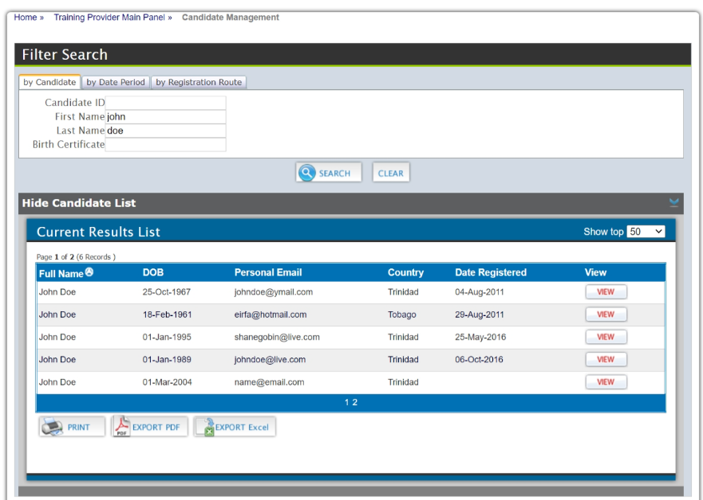
The Clear button clears the current search paraments entered.
From the list of candidates that satisfy the search parameters, click the View button next to the selected candidate. This will populate the area below the list with the personal information on the selected candidate.
Figure 8 Manage Candidate
It is recommended to search for an existing account for a candidate before creating a new candidate account to avoid duplication.

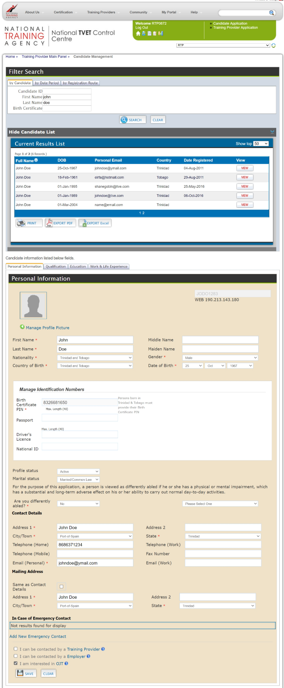  Figure 9 Candidate Summary | Some information can be edited e.g., the candidate’s name, address. The assessor can update the fields with the correct information and then click the Save button.  The assessor can also view TTNVQs/ CVQs awarded to the candidate by switching to the Qualification tab.  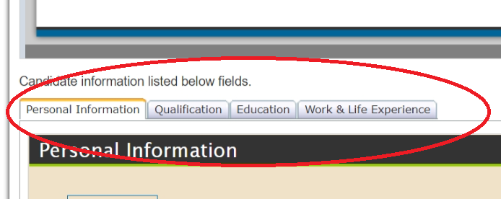  The Education tab displays any details, entered by the candidate, relating to their educational history.  The Work and Life Experience tab displays any details, entered by the candidate, relating to their work history.

Enrol Candidates into Cycle
Assessors can view and enrol candidates in a cycle. To access, click the link Enrol Candidates from the Assessor Main panel (Figure 5).

Viewing List of Candidates Enrolled to Cycle
To view the list of candidates already associated to the cycle, enter search parameters, if any, to refine list, and then click the Search button (see Figure 10).

Deleting Candidate – Cycle Association
First, view the list of candidates in the cycle. From the list, click the DELETE button for the relevant candidate to remove the association from the list.

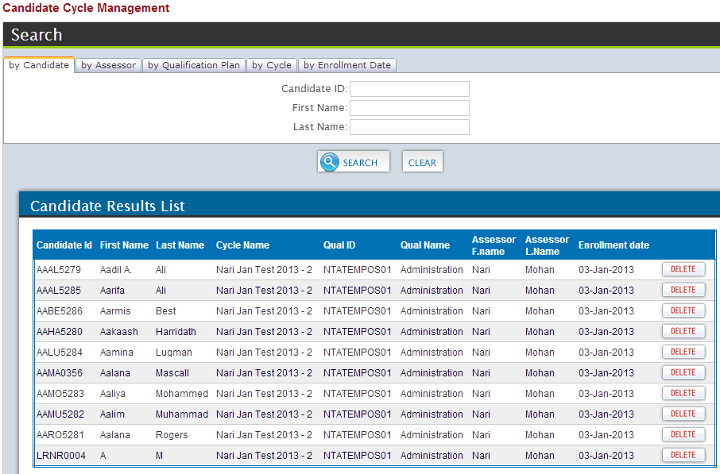
Figure 10 Candidate Cycle Management

Enrolling candidates into cycles
To enrol a candidate into a cycle,
- Click the Click to add candidate to cycle bar. The information for the selected cycle will appear.
- Select the relevant options from the dropdown lists
- The enrolment date can be adjusted as necessary.
- Search the list of registered active candidates by entering Candidate ID (or First name or Last name) and clicking the Search button. Select the candidates by clicking on the checkbox next to the appropriate candidate.
- Click the SAVE button to complete the association

Multiple candidates can be searched for and selected before clicking the SAVE button

Managing Candidates’ units
Assessors award units to candidates after successfully completing unit. To access, click the link Candidate Unit Awarding from the Assessor Main panel (Figure 5).

Viewing Candidates’ Units
To view the list of units already awarded to candidates, enter search parameters, if any, to refine list, and then click the Search button. (see Figure 11 below)
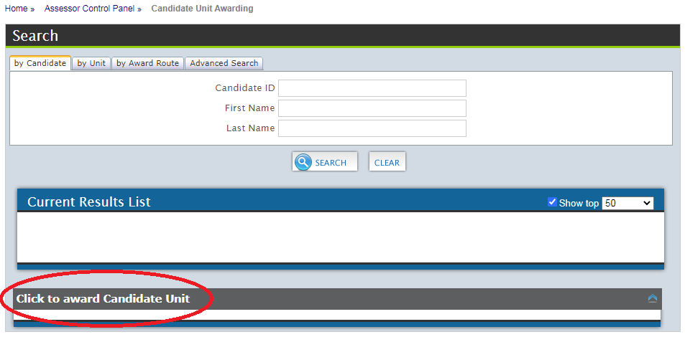
Figure 11 Candidate Unit Awarding Panel

Awarding Units to Candidates
To award (or verify) units for candidates, click the link Click to award Candidate Unit. (see Figure 11 above)
- Select the appropriate role for the selected cycle. That is whether the user is performing the role of Assessor, Internal Verifier or External Verifier.
- Then select the appropriate RTP, Cycle, Qualification Plan and Qualification Version from the available dropdown lists
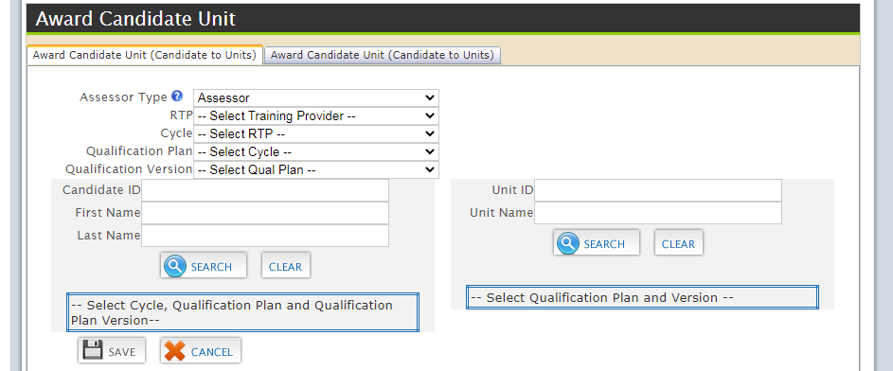
Figure 12 Awarding Unit(s) to Candidate(s)
- When all are selected, two lists may become available. The first being the list of candidates who have been assigned to the qualification plan for the cycle and the second, the list of units in the selected qualification plan. Select the relevant check boxes from both lists.
- After completing the selections, click the SAVE button.
- A pop-up window would ask for confirmation of the selections

Alternative Method to Awarding Units to Candidates
To award (or verify) units for one candidate, click the link Click to award Candidate Unit. (see Figure 11 above). Then click the second tab (seen in Figure 13).

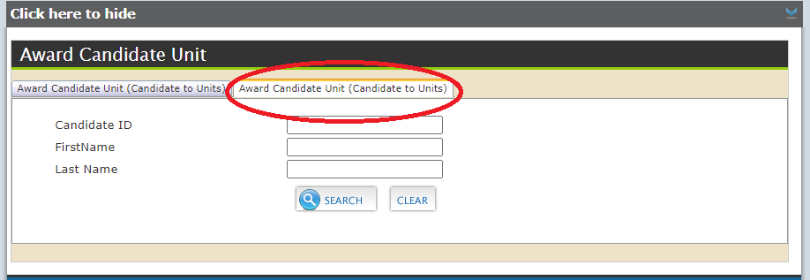
Figure 13 Another method of Awarding Unit(s) to Candidate(s)

- Search for the relevant candidate.
- When the candidate is found, the assessor can then click the VIEW button under the column heading Award Unit(s). (see Figure 14)
- Then select the appropriate Qualification Plan, Qualification Plan Version, Training Provider, Cycle from the available dropdown lists.
- This will load the units for the qualification plan. Select the relevant units for the candidate.
- Select the appropriate assessor type.
- After completing the selections, click the SAVE button.
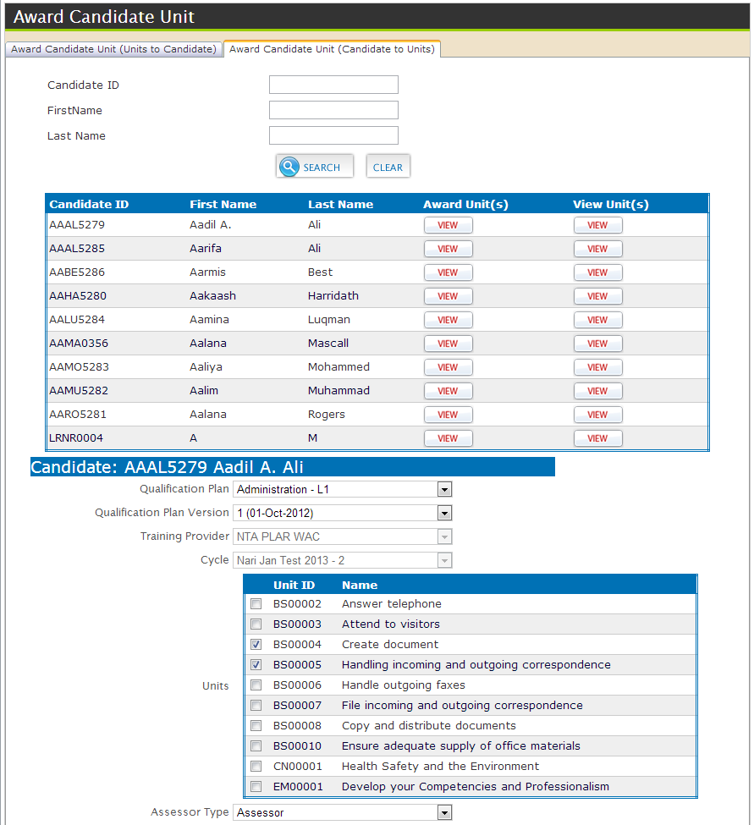
Figure 14 Another method of Awarding Unit(s) to Candidate

Awarding units to candidates via PLAR
Assessors award units to candidates after successfully completing unit via PLAR. To access, click the link Candidate PLAR Unit Awarding from the Assessor Main panel (Figure 5).
See section Managing Candidates’ units on page 14 as the process is similar.

Managing Cycle
Cycle Management allows the training providers to specify and manage the beginning and end of a training period and qualifications assigned through cycles on the TVETCC. The Training Provider has the responsibility to assign the candidates, assessors, and internal verifiers to a cycle.
After assessors have been assigned to a cycle, the assessors can then also enrol candidates in the cycle to pursue the qualification plan(s). To access click the link Manage Cycle from the Assessor Main panel (Figure 5). This will redirect the user to the Cycle Management panel (see Error! Reference source not found.Error! Reference source not found.).
Alternatively, from the navigation bar at the top by placing the mouse cursor over My Portal and selecting Cycle Processing from the dropdown list. Then click Manage Cycle link.

Viewing Cycles
Assessors can access the list of cycles to which they have been associated. To access, click the link Manage Cycle from the Assessor Main panel (Figure 5). Alternatively, from the navigation bar at the top by placing the mouse cursor over My Portal and selecting Cycle Processing from the dropdown list.
To view the list of cycles, enter search parameters, if any, to refine list, and then click the Search button.

Viewing List of Candidates Enrolled to Cycle
Assessors can then view the list of candidates registered to pursue the qualification plan(s) within the cycle. From the list of cycles, click the View button under the View Candidates column for the relevant cycle. Enter search parameters, if any, to refine list, and then click the Search button.
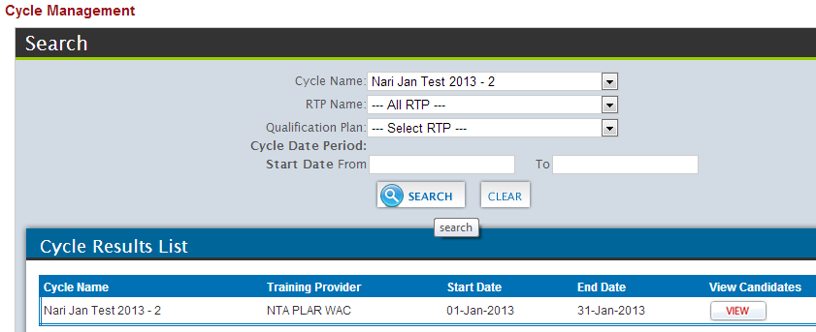
Figure 15 Cycle Management

Enrolling candidates into cycles
See section Enrol Candidates into Cycle on page 13

Managing PLAR
To access click the link Manage PLAR from the Assessor Main panel (Figure 5). This will lead to the Assessor PLAR Control Panel.
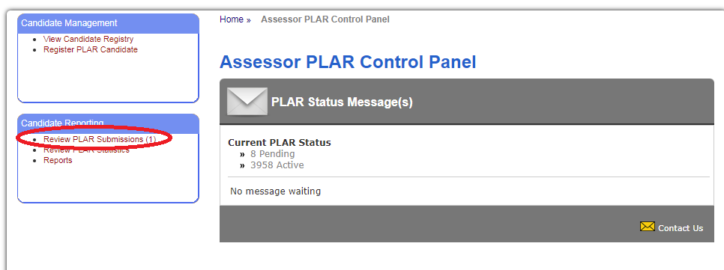
Figure 16 Assessor PLAR Control Panel
Reviewing PLAR Submission
Click the link Review PLAR Submissions to view PLAR Submissions. (see Figure 16)
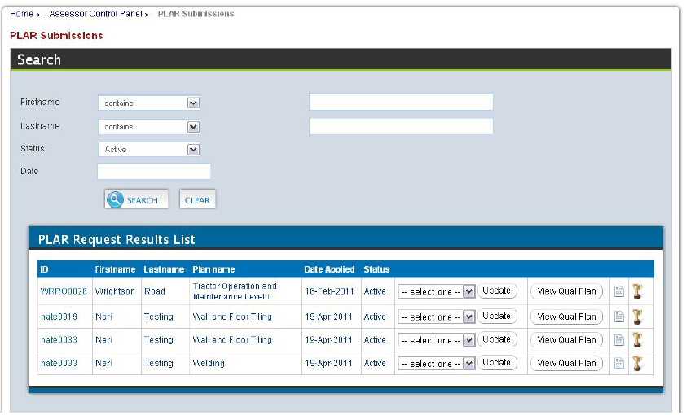
Figure 17 PLAR Submissions

Assessors can update the status for the plan by choosing a new status from the dropdown list and click the Update button.

Viewing Candidate Qualification Plan
From the PLAR Submission page(see Figure 17), click the View Qual Plan button, which will take the user to a page listing the details of the candidate’s PLAR Qualification Plan Listing. (see Figure 18).
This module allows the assessor to add further supporting evidence for the selected Qualification Plan by clicking the link Add S.E.

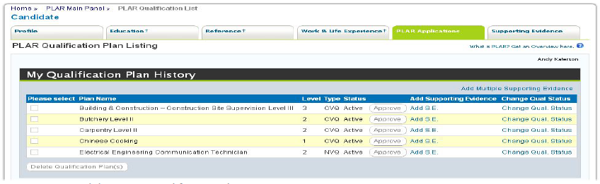
Figure 18 Candidate PLAR Qualification Plan Listing

Viewing Candidate Self-Assessment
From the PLAR Submission page(see Figure 17), click the icon , which will take the user to a page to view the candidates’ Self Assessments. (see Figure 19).
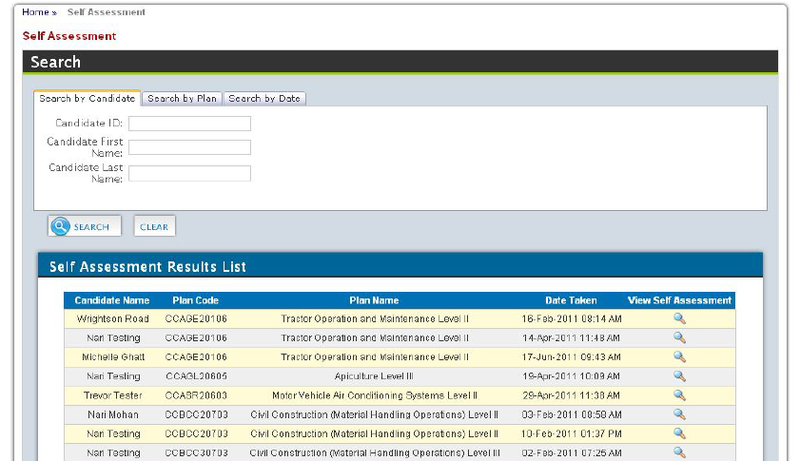
Figure 19 Candidate's Self-Assessments

This page displays the candidate’s Self -Assessment attempts. Assessors can view the details of each self-assessment by clicking the preview icon in the column View Self-Assessment (see Figure 19).
This would display the listing of the units for the qualification and what the candidate rated himself in terms of knowledge, skill and frequency. The assessor can then provide their own rating of the candidate for each unit in the qualification, then click Submit Assessment button.
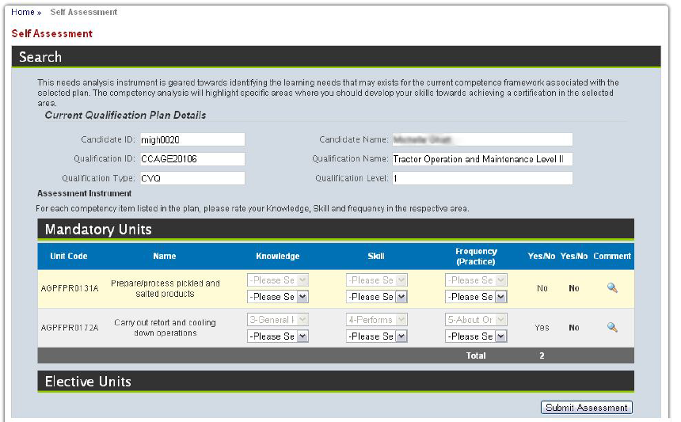
Figure 20 Candidate's Self-Assessment

Step-by-Step Guide for Assessors
This section is meant to assist assessors and internal verifiers to ensure the steps necessary towards the certification of their candidates on the TVETCC. The following are the necessary major steps:

Error Handling

Common Errors
Error | Possible Cause | Solution
Unable to login | Password is either incorrect or expired. | If forgotten, try Forgot my Password? Link (see page 6)  else send email requesting password reset
Unable to see required relevant cycle when awarding units | Assessor account not associated to relevant cycle | Request RTP to make the association to the relevant cycle.
Unable to see required candidates in cycle when awarding units | The units have already been awarded to the candidate(s). | No further action
 | Assessor account not associated to relevant qualification | Check list of assessors attached to the relevant qualification (see Assessor Search on page 9)

Help Facilities
Our technical support team is ready to answer questions that may arise or provide technical assistance in dealing with any issue(s) that may arise. Feel free to contact any of the following members of our support team
- Michelle Ghatt Deane, TVETCC, Senior Coordinator (michelle-ghatt@ntatt.org)
- Nari Mohan, Systems Analysts
- Rose Uche-Nawachi, Database Administrator
Email : tvetcc-support@ntatt.org

Appendix A - Glossary
Term | Definition
Assessor | A certified person authorized by an organisation to judge the performance of candidates against the occupational standards.
Candidates | An inclusive term referring to anyone learning, including students, apprentices, learners, interns; trainees, and people learning non-formally and informally as well as people enrolled for particular qualifications or part qualifications.
Centre Approval Process | The process that a centre must undergo to be granted permission by the Awarding Body to register and assess candidates for TTNVQs or CVQs
Certification | This is the process by which an approved centre requests, and the Awarding Body provides, a certificate for each candidate on completion of:  ♦ the entire set of units required for the award of the CVQ  ♦ one or more units of an CVQ (for those candidates not enrolled for a full CVQ
CVQ | The Caribbean Vocational Qualification (CVQ) is an award that represents achievement of a set of competencies which define core work practices of an Occupational area, consistent with the levels articulated within the regional qualifications framework. To earn an award, candidates must demonstrate competence in reaching CARICOM-approved occupational standards developed by practitioners and employers (i.e. the industry experts). These standards are organized in units. Candidates may earn unit awards towards achieving a complete CVQ.
Cycle | The time period stipulated for the delivery of training.
External Verifier | An External Verifier is an individual contracted by the Awarding Body to carry out a Quality Assurance Audit of the CVQ provision in an approved Centre to ensure that centres approved to offer CVQs are consistently judging candidates equally, fairly and in accordance with the regional occupational standards.
Internal Verifier | A person nominated by an approved centre who is responsible for internal quality assurance, mainly through assuring the quality and consistency of assessments by Assessor(s).
Satellite centre | Additional training centres (or sites) operating in a different location from the main training provider
Training Provider | An institute, enterprise or community-based organisation which provides training and/or facilitates the training process for the acquisition of competences in keeping with occupational and national standards, accredited facilities and vocational qualifications, and appropriate resources
TVET | Technical and vocational education and training’ (TVET) is understood as comprising education, training and skills development relating to a wide range of occupational fields, production, services and livelihoods.  TVET, as part of lifelong learning, can take place at secondary, post-secondary and tertiary levels and includes work-based learning and continuing training and professional development which may lead to qualifications. TVET also includes a wide range of skills development opportunities attuned to national and local contexts. Learning to learn, the development of literacy and numeracy skills, transversal skills and citizenship skills are integral components of TVET.  Source: UNESCO (GC) 2015, UN
Unit | Units are a set of learning outcomes (knowledge, skills and attitude) which constitute a coherent part of a qualification. A unit can be the smallest part of a qualification that can be assessed, transferred, validated and, certified. A unit can be specific to a single qualification or common to several qualifications.

